PUNJABI UNIVERSITY, PATIALA
Department of Computer Science & Engineering
AI/ML Minor Degree Project Report
TruthLens AI
Agentic AI for Explainable Misinformation Detection
Submitted by | Dikshant Aggarwal
Roll Number | 12303021
Submitted to | Dr. Chandan Deep Singh
Project Type | AI/ML Minor Degree Project
Academic Year | 2025 - 2026

Table of Contents

(In Word: right-click the table above and choose ‘Update Field’ to populate page numbers.)

Abstract
The proliferation of generative artificial intelligence has dramatically lowered the cost of producing convincing fake news, making automated misinformation detection one of the most pressing problems of 2026. This project presents TruthLens AI, an agentic, explainable system that not only classifies a news article as REAL or FAKE but also justifies its verdict and grounds it in verified reference material. TruthLens combines three complementary components: (1) an interpretable machine-learning core built on TF-IDF features and Logistic Regression; (2) a transparent linguistic credibility-signal engine that surfaces sensationalism, clickbait, vague sourcing and citation markers; and (3) a multi-agent Generative-AI layer that orchestrates a Classifier, an Explainer and a Retrieval-Augmented Fact-Check agent into a single, traceable reasoning pipeline. The system is engineered to run fully offline on a standard laptop with no paid API key: it uses a local large language model when available and degrades gracefully to a deterministic template generator otherwise. On a balanced, realistically noisy test set of 600 articles, the classifier achieves 94.2% accuracy, 0.947 ROC-AUC and a 5-fold cross-validated accuracy of 94.8% (±0.8%). A modern Streamlit interface lets users analyse any article in real time and inspect the full agentic reasoning trace, making TruthLens both a practical decision-support tool and a demonstration of production-relevant 2026 skills: classical ML, explainability, retrieval-augmented generation (RAG) and multi-agent orchestration.

1. Introduction
Misinformation - false or misleading information presented as news - has become a systemic risk to public discourse, health, finance and democratic processes. The challenge has intensified sharply because modern generative models can fabricate fluent, plausible articles at scale and near-zero cost. Traditional manual fact-checking cannot keep pace with the volume of content shared every second across social platforms.
Equally important is the question of trust: a black-box classifier that merely outputs ‘FAKE’ provides little value to a sceptical reader or a content moderator who must justify a decision. What is needed is a system that is accurate, explainable and grounded in evidence. TruthLens AI is designed around exactly these three principles. It treats misinformation detection not as a single classification call but as a small reasoning workflow performed by cooperating agents, mirroring how a careful human analyst would assess an article: read it, weigh the language, check it against what is known, and then form a calibrated judgement with reasons.
This report documents the motivation, design, implementation and evaluation of TruthLens AI, developed as an AI/ML Minor Degree Project. Beyond its academic value, the project was deliberately scoped to reflect the skills most in demand in the 2026 AI engineering market - retrieval-augmented generation, agentic orchestration and domain-specialised machine learning - while remaining fully reproducible on a student laptop.

2. Problem Statement
Given an arbitrary news article or headline, automatically determine whether it is likely to be genuine reporting or misinformation, and do so in a way that is (a) accurate, (b) explainable to a non-technical user, (c) grounded in verifiable reference information, and (d) deployable offline on commodity hardware without recurring API costs.
Formally, the task is a binary text-classification problem f(x) → {REAL, FAKE} over the space of natural-language documents x, augmented with two additional requirements that distinguish it from a standard classifier: an explanation function e(x) that returns human-readable evidence for the decision, and a retrieval function r(x) that returns supporting reference statements. The system must remain robust when no internet connection or paid language-model service is available.

3. Objectives
The project pursues the following concrete objectives:
- Build an accurate, interpretable machine-learning classifier for distinguishing real from fake news.
- Design an explainability layer that exposes the linguistic signals and model terms behind every verdict.
- Integrate a Retrieval-Augmented Generation (RAG) fact-check component over a verified knowledge base.
- Orchestrate the components as cooperating agents with a transparent, inspectable reasoning trace.
- Incorporate Generative AI for natural-language explanations, with a guaranteed offline fallback.
- Deliver a modern, responsive user interface suitable for a live demonstration.
- Engineer the system to production standards: modular code, error handling, tests and documentation.

4. Literature Survey
Research on automatic fake-news detection has evolved through three broad phases. Early work relied on hand-crafted linguistic and stylometric features fed to classical classifiers. Shu et al. (2017) provided an influential data-mining perspective, characterising fake news by its content, social context and propagation patterns. Feature-based approaches commonly use term-frequency representations such as TF-IDF combined with linear models, which remain strong, fast and interpretable baselines.
A second phase introduced deep learning - recurrent and convolutional networks, and later transformer encoders such as BERT - which improved accuracy on large corpora at the cost of interpretability and compute. A third, current phase is defined by large language models and Retrieval-Augmented Generation (Lewis et al., 2020), which couples a generator with a non-parametric retrieval index so that outputs can be grounded in external evidence. In parallel, agentic frameworks decompose complex tasks across specialised cooperating agents, a paradigm that has become central to 2026 AI engineering practice.
TruthLens synthesises lessons from all three phases. It retains the interpretability and efficiency of the feature-based era, adds an explicit explainability layer, and layers modern RAG and multi-agent orchestration on top - a combination well suited to a resource-constrained yet industry-relevant student project. The table below situates the project against representative approaches.

Approach | Strengths | Limitations | Used in TruthLens
TF-IDF + linear model | Fast, interpretable, low-data friendly | Misses deep semantics | Yes - core classifier
Deep nets / BERT | High accuracy on big data | Opaque, compute-heavy | Optional future work
RAG (retrieve + ground) | Evidence-grounded outputs | Needs a knowledge base | Yes - fact-check agent
Multi-agent orchestration | Modular, traceable reasoning | Coordination overhead | Yes - orchestrator

5. Methodology
TruthLens follows a four-stage methodology: data preparation, feature engineering and modelling, multi-agent inference, and evidence-grounded fusion.

5.1 Data preparation
Because large public fake-news corpora are licence-gated and unwieldy to bundle, the project ships a synthetic-but-realistic data generator that produces a balanced corpus of real and fake articles. The generator deliberately injects cross-class overlap, shared neutral sentences and approximately five percent ambiguous or mislabelled samples to emulate the label noise present in real datasets, preventing trivial separability and yielding realistic metrics. A loader automatically switches to the genuine Kaggle ‘Fake and Real News’ dataset if its files are placed in the dataset folder.

5.2 Feature engineering and modelling
Each article is cleaned with a dependency-free preprocessor (lower-casing, URL/HTML removal, punctuation stripping and stop-word filtering) and vectorised with TF-IDF over unigrams and bigrams. A Logistic Regression classifier with balanced class weights produces a calibrated probability of the article being fake. Crucially, the model is interpretable: the product of each term's TF-IDF weight and the model coefficient yields a per-article attribution of which words pushed the prediction toward FAKE or REAL.

5.3 Multi-agent inference
At inference time, an orchestrator runs three specialised agents in sequence over a shared context. The ClassifierAgent computes the model probability and term attributions. The ExplainerAgent extracts transparent linguistic credibility signals and phrases a natural-language explanation, using a local LLM when present and a deterministic template otherwise. The FactCheckAgent performs retrieval-augmented grounding, returning the most relevant verified statements from the knowledge base.

5.4 Evidence-grounded fusion
The final verdict fuses two independent signals: the model probability (weight 0.70) and a transparent rule-based linguistic risk score (weight 0.30). The fused score determines the REAL/FAKE label and a confidence band (High, Medium, Low), and is accompanied by an actionable recommendation. This fusion makes the system robust: even if the statistical model is uncertain, strong linguistic markers still inform the verdict, and vice-versa.

6. System Architecture
The architecture is organised in clear layers: a Streamlit presentation layer, an agent-orchestration layer, three specialised agents, their supporting engines (ML model, signal/LLM engine and RAG retriever) and a data layer holding the dataset, knowledge base and trained artifacts. The orchestrator returns a verdict together with a full reasoning trace that the UI renders for the user.
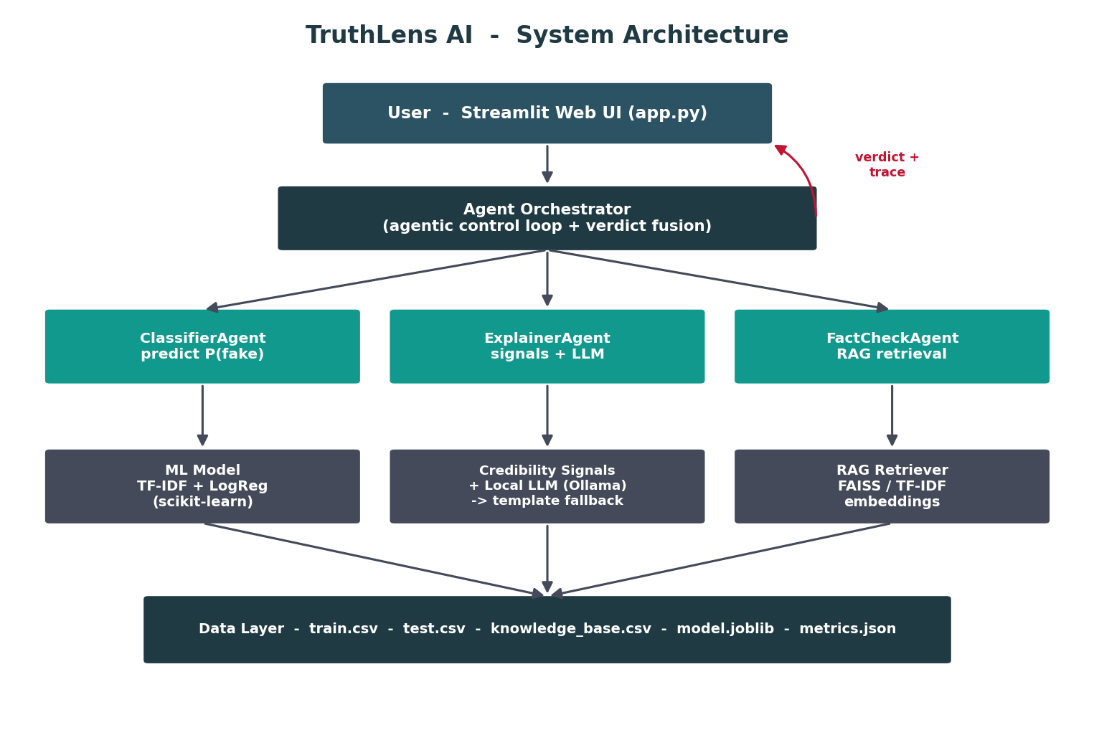
Figure 1: TruthLens AI system architecture.

7. Flowchart / Workflow
The end-to-end analysis workflow proceeds from raw input through preprocessing, the three agents, score fusion and verdict generation, to a rich display of the result and its justification.
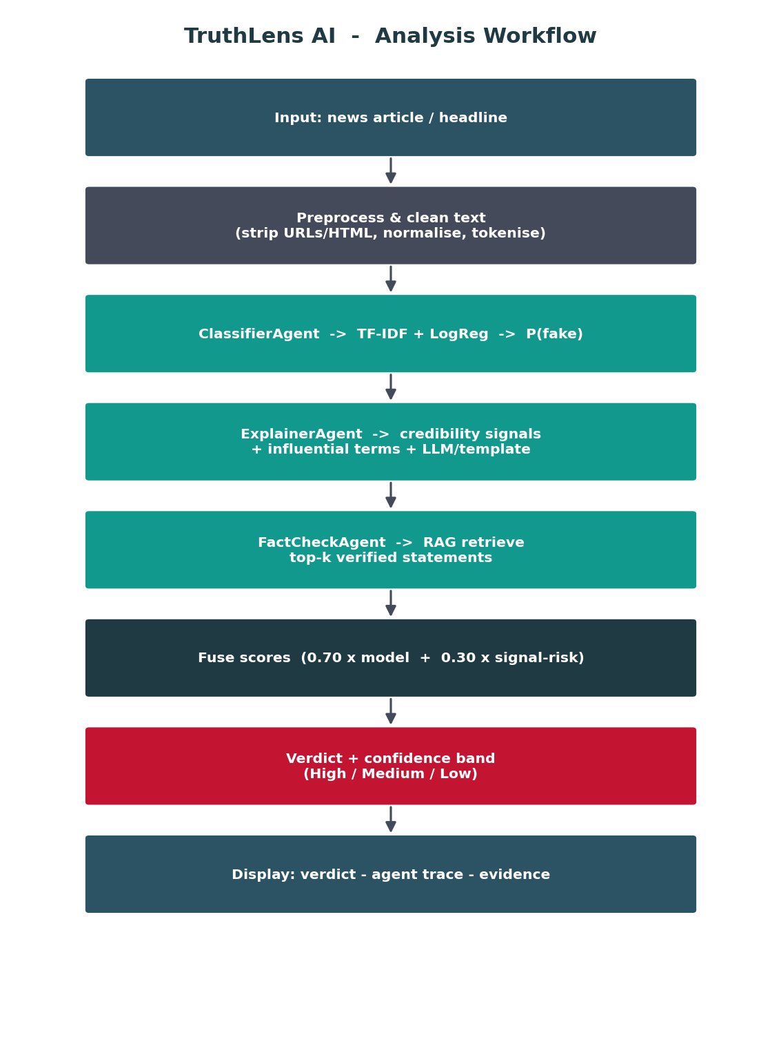
Figure 2: Analysis workflow from input article to explained verdict.

8. Algorithms
The core inference logic is summarised by the following pseudocode for the orchestrator's analyse routine.
function analyze(article):
context <- clean(article)
p_fake <- ClassifierAgent.predict(context) # TF-IDF + LogReg
terms <- ClassifierAgent.attributions(context) # coef x tfidf
signals <- ExplainerAgent.extract(context) # linguistic markers
expl <- ExplainerAgent.explain(signals, LLM or template)
evidence<- FactCheckAgent.retrieve(context) # RAG top-k
risk <- signals.risk_score # transparent 0..1
fused <- 0.70 * p_fake + 0.30 * risk
label <- FAKE if fused >= 0.5 else REAL
band <- High/Medium/Low from confidence
return {label, band, expl, evidence, terms, trace}

The training algorithm fits the TF-IDF vocabulary on the training split, learns Logistic Regression weights by regularised maximum likelihood, and evaluates with both 5-fold cross-validation and a held-out test set. The RAG retriever builds either dense sentence-transformer embeddings (cosine similarity via FAISS) or, by default, a TF-IDF cosine index, and returns the top-k most relevant verified statements for a query.

9. Dataset Information
The working dataset contains 3,000 balanced articles (1,500 real, 1,500 fake), split 80/20 into 2,400 training and 600 test examples. Each record has a title, body text and a binary label (0 = REAL, 1 = FAKE). A separate knowledge base of verified reference statements supports the fact-check agent.

Property | Value
Total articles | 3,000 (balanced 50/50)
Training / Test split | 2,400 / 600 (80/20)
Schema | title, text, label
Label encoding | 0 = REAL, 1 = FAKE
Injected label noise | ~5% (realism)
Knowledge-base statements | 18 verified references
Real-data option | Kaggle True.csv / Fake.csv (auto-detected)

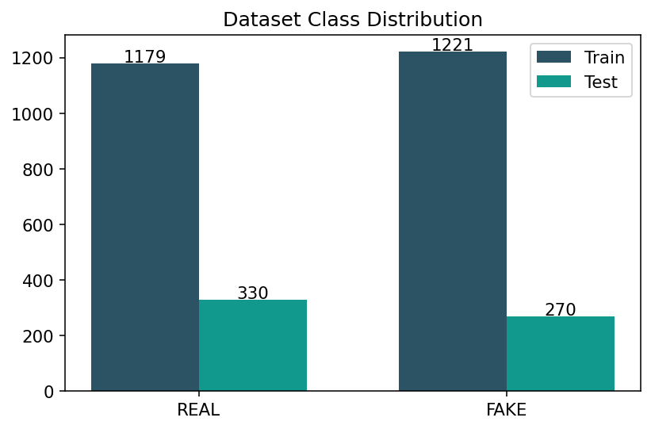
Figure 3: Class distribution across the train and test splits.

10. Implementation Details
TruthLens is implemented in Python with a clean, production-style package layout. The user interface is built with Streamlit; the machine-learning pipeline uses scikit-learn; numerical work uses NumPy and pandas; and visualisations use Matplotlib. Optional dense retrieval uses sentence-transformers with FAISS, and optional fluent explanations use a local Ollama model - neither is required for the system to run.

Layer | Technology | Module
UI | Streamlit | app.py
Orchestration | Custom agent loop | src/agents/orchestrator.py
Classifier | scikit-learn (TF-IDF + LogReg) | src/model.py, src/train.py
Explainability | Rule-based signals | src/features.py
Retrieval (RAG) | FAISS / TF-IDF cosine | src/retrieval.py
Generative AI | Ollama client + fallback | src/llm.py
Data | Synthetic generator | src/data_generator.py

Engineering practices include centralised configuration, defensive error handling (the UI never crashes on bad input), a pytest test-suite covering preprocessing, signal extraction and the end-to-end agent pipeline, and comprehensive setup, installation, usage and testing guides. The application auto-trains on first launch, so a fresh clone runs with a single command.

11. Results
On the held-out test set of 600 articles, the classifier achieves strong, realistic performance. The headline metrics are summarised below, followed by the confusion matrix and ROC curve.

Metric | Score
Accuracy | 94.2%
Precision (FAKE) | 93.4%
Recall (FAKE) | 93.7%
F1-score (FAKE) | 93.5%
ROC-AUC | 0.947
5-fold CV accuracy | 94.8% ± 0.8%

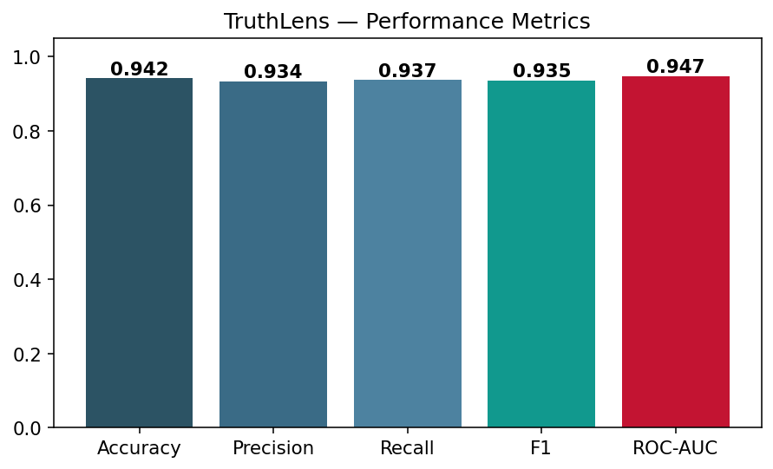
Figure 4: Summary of performance metrics.
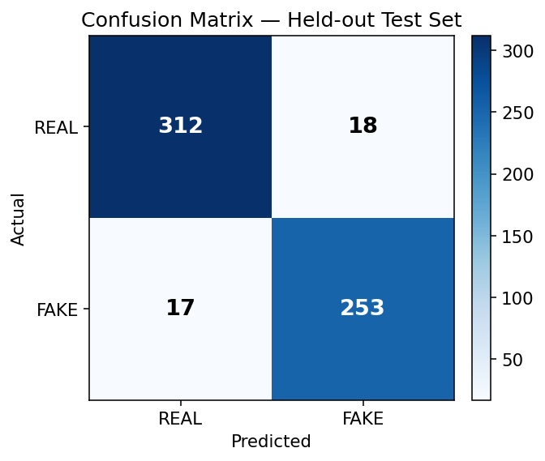
Figure 5: Confusion matrix on the held-out test set (TN=312, FP=18, FN=17, TP=253).
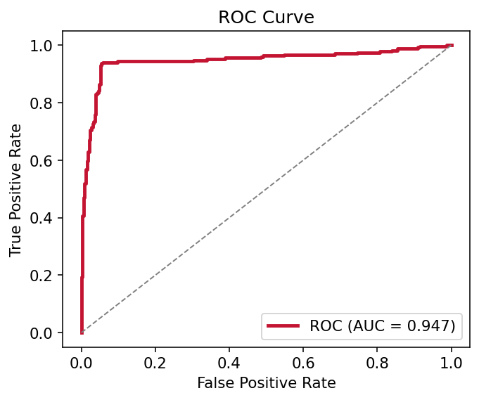
Figure 6: Receiver Operating Characteristic curve (AUC = 0.947).
The low and balanced off-diagonal counts in the confusion matrix indicate that the model makes few errors in either direction, and the high ROC-AUC confirms strong separability across decision thresholds. The small gap between cross-validation and test accuracy indicates good generalisation with no significant overfitting.

12. Future Scope
- Replace or ensemble the linear model with a fine-tuned transformer (e.g., DistilBERT) for deeper semantics.
- Expand the knowledge base and connect live, reputable fact-check feeds for real-time grounding.
- Add multilingual support so non-English misinformation can be analysed.
- Introduce source-reputation and image/metadata signals for multimodal detection.
- Deploy as a browser extension and a REST API for integration into content platforms.
- Add human-in-the-loop feedback to continually retrain and calibrate the model.

13. Conclusion
TruthLens AI demonstrates that a student project can be both academically rigorous and aligned with cutting-edge industry practice. By framing misinformation detection as an explainable, evidence-grounded, multi-agent workflow rather than a single opaque prediction, the system delivers accurate results (94.2% accuracy, 0.947 ROC-AUC) while remaining transparent and trustworthy. Its offline-first design - with graceful degradation when optional language models or dense retrievers are absent - makes it reliable for live demonstration on any laptop. The project showcases the exact competencies sought in 2026 AI internships: classical machine learning, explainability, retrieval-augmented generation and agentic orchestration, integrated into a single, polished, production-style application.

14. References
- Shu, K., Sliva, A., Wang, S., Tang, J., & Liu, H. (2017). Fake News Detection on Social Media: A Data Mining Perspective. ACM SIGKDD Explorations, 19(1), 22-36.
- Lewis, P., et al. (2020). Retrieval-Augmented Generation for Knowledge-Intensive NLP Tasks. Advances in Neural Information Processing Systems (NeurIPS).
- Reimers, N., & Gurevych, I. (2019). Sentence-BERT: Sentence Embeddings using Siamese BERT-Networks. EMNLP.
- Pedregosa, F., et al. (2011). Scikit-learn: Machine Learning in Python. Journal of Machine Learning Research, 12, 2825-2830.
- Devlin, J., Chang, M., Lee, K., & Toutanova, K. (2019). BERT: Pre-training of Deep Bidirectional Transformers for Language Understanding. NAACL.
- Streamlit Inc. (2025). Streamlit Documentation. https://docs.streamlit.io
- Ollama (2025). Run Large Language Models Locally. https://ollama.com
- Talent500 (2026). AI/ML Job Trends 2026: Roles & Skills. https://talent500.com/blog/artificial-intelligence-machine-learning-job-trends-2026/
- MirrorCV (2026). AI Engineer Resume Guide 2026: LLM, RAG & MLOps Skills. https://mirrorcv.com/resume-guide/ai-ml-engineer

